

Project: Shah Sachal Sami aein USAID Jo pegam: “Karyo Ilam Khe Aam”
By Small Grants and Ambassador’s Fund Program, USAID Pakistan Implemented by Shah Sachal Sami Foundation, Nawabshah
Breaking The Tradition
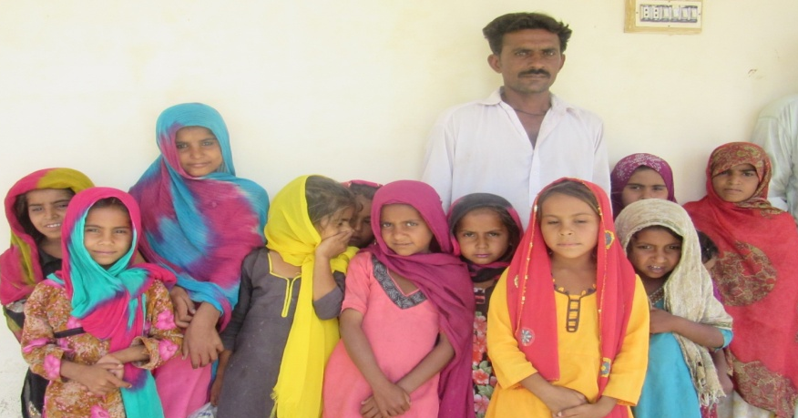
Village Yateem Lashari is situated in UC Sawari, Taluka Qazi Ahmed, District Shaheed Banizrabad. The village is comprised of more than 30 households belonging to Lashari community, a branch of Balouch tribe. The community is known to be fundamentalist in terms of allowing the girls to have the right to education. Due to entrenched custom majority of young girls and women used to live life without the jewel of education. The situation was so much so abysmal that they even could not read and write their own names.

The situation was unearthed during the baseline survey of Shah Sachal Sami aein USAID jo pegam “Karyo Ilm Khy Aam Project”. Realizing the severity and appalling state, Shah Sachal Sami Foundation project team specially selected the village to conquer the challenge. In this connection, firstly community meeting with the veterans and male community members was held amid at sensitizing them about the importance of education including girls’-education. As the second tactic Project Team identified four Ilm-Ambassadors and motivated them to join in to break tradition and bring the prospect of prosperity of better future for girls. The selected Ilm-Ambassadors from village were trained by shah Sachal Sami foundation at village Sher Poriyan.

Ali Ahmed, Ghulam Qadir, Adil and Ali Gul commenced the assigned tasks and conducted household survey to identify the out of school children aging 7-11 specially targeting the girls. However they were flagrantly smeared by some community members but the Ilm-Ambassadors and Project Team remained steadfast and committed to the target. Door-to-door work was undertaken by the Ilm-Ambassadors and project message was imparted to parents to encourage them to submit their daughters in schools so as adheres with jewels of education. As a result in remarkable and historic shift, 12 out of school girls of the village have been enrolled in the GBPS Yateem Lashari.

They are very first girls to attend a school on regular bases and unprecedentedly their parents have also thrown their weights behind the enrolled girls to ensure their girls to be regular in the school and acquire the education.

Muhammad Mindad, grandfather of one of the girls and Muhammad Mithal, father of one of enrolled girls, stated, “it’s new phenomena for the community to allow the girls to attend the school on regular bases however our boys motivated us about importance of girls education, which has inspired us therefore now we are happy to see them getting education”.

______________________________________
The project has been funded by the American people through the U.S. Agency for International Development
under the Small Grants and Ambassador's Fund Program.

